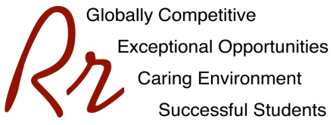

Rocky River City Schools
Kensington Intermediate School

Grade 3 Supply List – All Classes

2022-2023

The following yearly fee is charged for all students. This fee is for materials and supplies, which will be used during the year. Fees may be paid by CASH or CHECK, made payable to Kensington Intermediate School. To avoid confusion EACH child should have his/her own check or cash for fees. Fees may also be paid along with milk/juice accounts via EZpay found here: https://www.spsezpay.com/RockyRiver/login.aspx

MATERIALS FEE$55.00

In addition, the following items need to be purchased outside of school:

- Headphones or earbuds
- 24 Crayons
- 24 Sharpened Pencils
- 12 Colored Pencils
- 1 Highlighter
- 4 Jumbo Glue Sticks for class
- 1 Pink Eraser
- 2 Pack Post-It Notes
- Scissors – Intermediate Size
- 4 Durable pocket folders: red, blue, yellow, green (one of each color)
- Markers - Set of 8
- 8 Dry Erase Markers (Expo low odor variety)
- 4 Composition Books with Lined Paper
- Art Shirt/Smock
- 2 containers of Antibacterial Wipes
- 2 Box of Tissues
- A-M last names sandwich bags
- N-Z last names gallon bags
- Tennis shoes must be worn on fitness day.

Separate Supplies for art class:
- Markers- set of 8
- Glue stick
- 2 Pencils
- Black Sharpie marker

********* PLEASE PLACE STUDENT NAMES ON ALL ITEMS *********
PLEASE REPLENISH SUPPLIES AS NEEDED.

